

**eSchoolPlus 4.0**

L**

**STUDENT REGISTRATION**

Contents

Registering Students for Summer School 3

Summer School Secondary Homeroom 4

Summer School Transportation Program Code 5

Transportation Program Code: 5

Identify the appropriate Summer School Program Code(s) in the identified area: 5

Students Not Needing ANY Summer School Transportation 6

Students Not Needing Transportation To OR From Summer School 6

Instructions for Adding Summer School Contact Information 7

Contact Type 7

Relationship Code 7

To add a Summer Child Care Provider 8

# Registering Students for Summer School

Make sure you are in the current school year environment to register summer school students.

Upon receipt of the summer school registration form, perform the following steps:

1. Search the student to be registered for the summer program
2. Click the student name
3. Follow this path from the menu:

**Registration > Entry & Reports > Student Demographic > Entry/Withdrawal**

Make sure the student does not already have a current year summer school line identified in the Summer School Year area.

1. Scroll down to Summer School section

In the Summer School Year section of the Entry/Withdrawal screen click the + icon on the Summer School header

1. The Entry/Withdrawal Details screen will appear
2. **School Year**: Should reflect the current school year
3. **Building**: Enter the correct summer school building – See the Summer School Program Sheet for appropriate SS Building number and registration information to be identified.
   1. 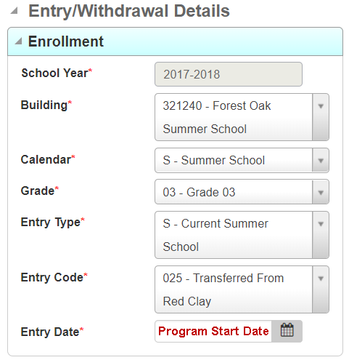*Note: All Summer School Buildings start with 321. Be sure you select the 32****1*** *building from the drop-down arrow or type* ***321building number*** *for the correct summer school site.*
4. **Calendar**: S – Summer School should fill-in, if not select from the drop-down arrow
5. **Grade**: Should be listed, if not select the current grade the student is participating
6. **Entry Type**: S – Current Summer School should be identified, if not select from drop down arrow.
7. **Entry Code**: 025 – From Red Clay
8. **Entry Date**: 1st day of the summer school program
   1. *Note: Summer school programs start dates vary and multiple programs are in the same building. Be sure to enter the correct program start date the student is participatin**g in as identified on the Summer School Program Sheet.*
9. **Save**

When you return to the Entry/Withdrawal screen, you will see the student has a current year summer school record under the Summer School Year header:

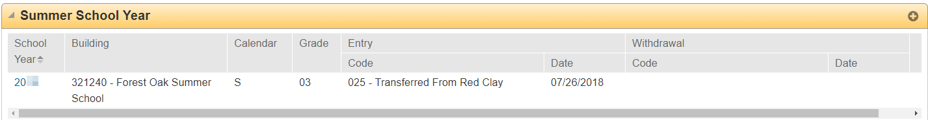

# Summer School Secondary Homeroom

**Purpose**: Summer sites with multiple programs need secondary homerooms to identify which students are in which program for participating purposes. Allows the Summer Coordinator/ Administrator to search/view students applicable to that specific program.

***Note****: This information is identified on the Summer School Program sheet. If there is not a secondary homeroom identified on the Summer School Program sheet, this step can be skipped.*

From the regular school year environment, once the summer school registration is entered for the student, follow this path:

**Registration > Entry & Reports > Student Demographic > Registration**

When the Registration screen opens look for the Summer School area:

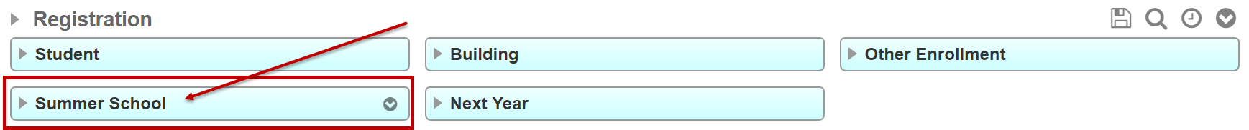

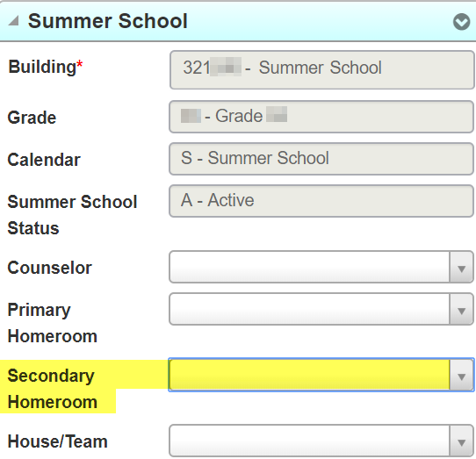

In the Summer School area there is a Secondary Homeroom field. Use the drop-down arrow in the Secondary Homeroom field to identify the applicable program code listed on the Summer School Program sheet.



Be sure to Save

# Summer School Transportation Program Code

This screen must be reviewed for all students registered to attend a summer program. Update as applicable.

To get to the Transportation Program Code screen, follow this path:

**Registration > Entry & Reports > Student District Defined > Transportation Program Code**

## Transportation Program Code:

In order for summer transportation to be routed accurately, some summer sites with multiple programs have Summer School Transportation Program Codes to identify which students have different start/end times and/or the special education programs.

Summer School Transportation Program Code(s) are identified on the Summer School Program sheet. Not all programs have a program code.

* SS Program Code 1: Pertains to the student’s summer school program
* SS Program Code 2: Identifies if the student has any restraints for transportation (wheelchair, seatbelt, car seat…)

**Regardless, if your program has a Summer School Transportation Program Code or not, you still must come to this screen** to determine if there is already a Summer School Program Code 1 or 2 identified that needs to be changed/removed. Update as applicable and if you are not sure please contact the transportation department for verification.

## Identify the appropriate Summer School Program Code(s) in the identified area:

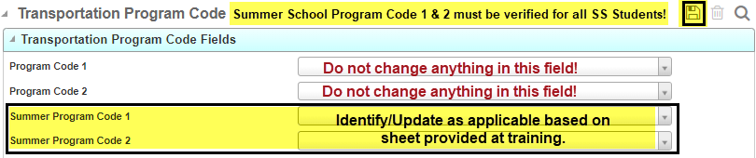

***Note****: Do not make any change to Program Code 1 or Program Code 2 – this is for the regular school year.*

## Students Not Needing ANY Summer School Transportation

**Any student that is identified as not needing any transportation** both to and from the summer program should be tagged as “NT” for Summer Program Code 1 on the Transportation Program Code screen. Here is how to do it:

**Registration > Entry & Reports > Student District Defined > Transportation Program Code**

On the Transportation Program Code screen, **tag NT to Summer Program Code 1** for these students.

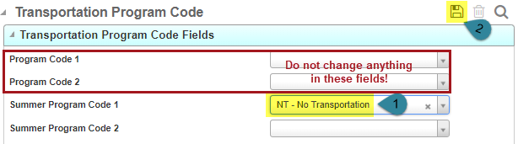

## Students Not Needing Transportation To OR From Summer School

For those students not needing transportation to or from summer school please develop a list to provide to the transportation department. The list should include the following information:

* Summer school site
* Summer Program student is participating in
* Student name
* Student ID#
* Note if transportation is not needed to or from school

Forward the list to Kelly Shahan, Transportation Department, by the registration deadline.

# Instructions for Adding Summer School Contact Information

Summer school addresses are designed to work through specific Contact Types and Relationship Codes.

Follow this path to the Contact screen:

**Registration > Entry & Reports > Student Demographic > Contacts**

or click the lightning bolt from the Contact area of the Student Summary screen

Summer contacts added to the student’s record must be identified as follows:

Contact Type: O – Other Contact.

***Note****: Do* ***not*** *select emergency or guardian!* ***All*** *summer contacts are* ***O*** *– Other Contact.*

Relationship Code: Relationship Codes identify the type of transportation needed. Categories are shown below:

* **SSH** - Transportation address is the same as student’s physical address
  + - Nothing to do
    - The nightly update will generate a summer school transportation record (*this will be in the student’s name*) with a relationship code of SSH – Summer School Home/Physical.

*NOTE:* *These records will appear on the Contact Exception Circular Reference and Student-to-Student Links – it is okay, do not delete them. Share with others who update the Contact Exception reports.*

* **SST** - Transportation to and from summer site is different than student’s physical address
  + - Add contact tag relationship code SST – Summer School Transportation
* **SSTT** - Transportation to summer site is different than student’s physical address
  + - Add contact tag relationship code SSTT - Summer School Transportation To school only
* **SSTF** - Transportation from summer site is different than student’s physical address
  + - Add contact tag relationship code SSTF - Summer School Transportation From school only

*FYI: SST, SSTT, and SSTF Relationship codes override SSH, the SSH will still show as a contact.*

* 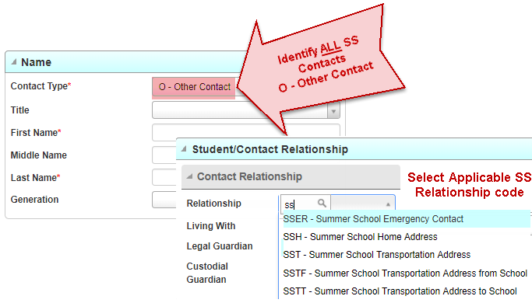**SSER** – This is **NOT** a transportation code! Summer School Emergency Contact *(Note: If the contact is already listed as an emergency no need to add the contact to the students record again as it will be a duplicate)*

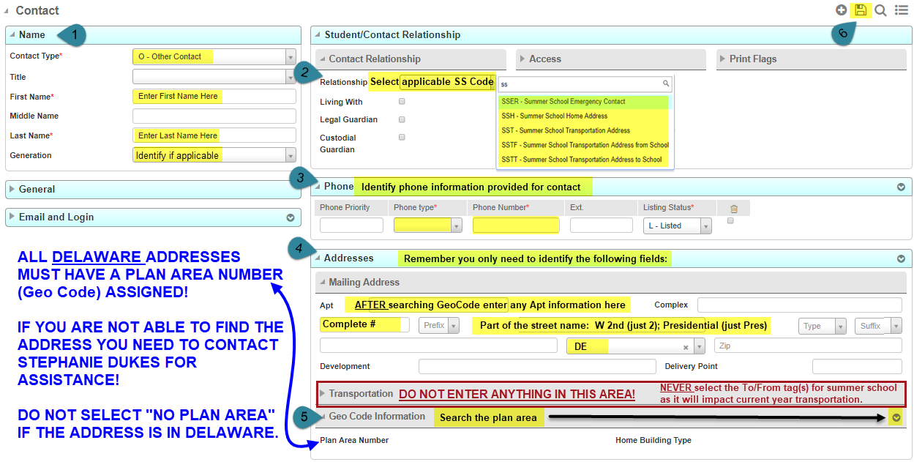**\*\*\*Important:** The check boxes for “Transport to school” and “Transport from school” **must be left unchecked** for all the summer school contact types. If you check them, it will interfere with the regular school year transportation addresses.

To add a Summer Child Care Provider:

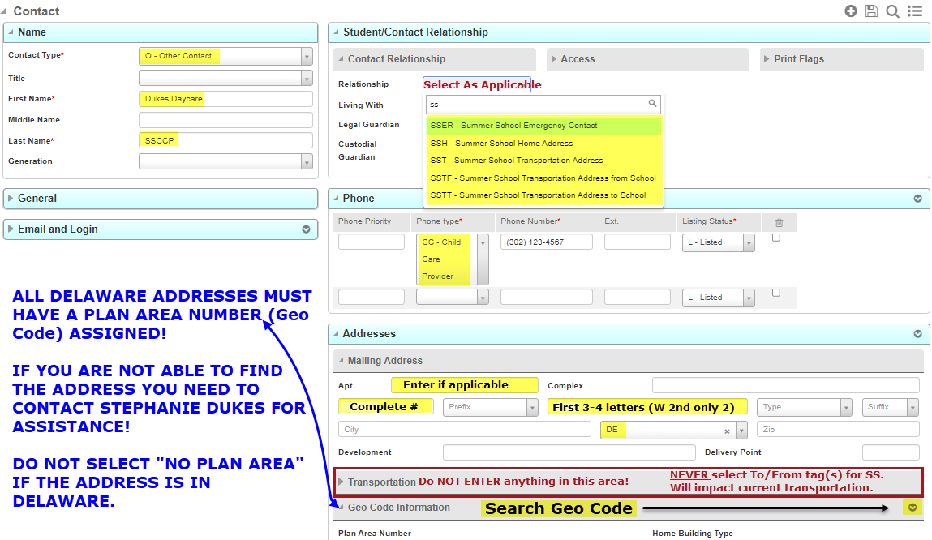Use the last name **SSCCP** first name should be the name of the facility (i.e.: Dukes Daycare). You still have to tag the Contact Type of Other and the Relationship Code as SST, SSTT, or SSTF. The phone number code should be: CC – Child Care Provider.